Central Nervous System (CNS) Date:

Outline the parts of the nervous system that make up the CNS
Protection of the CNS: Bone
Protection of the CNS: meninges | 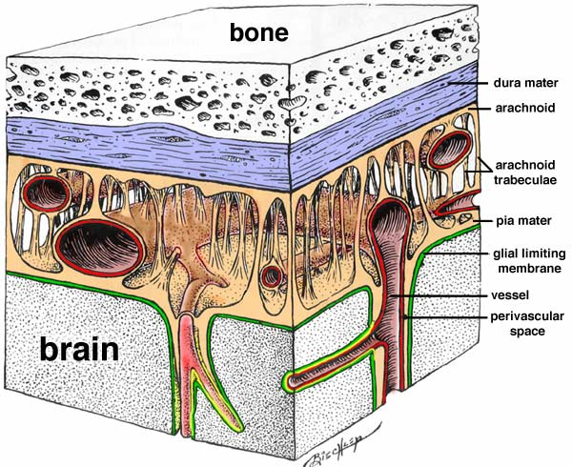
Protection of the CNS: Cerebrospinal fluid (CSF)
Structure of the cerebrum | 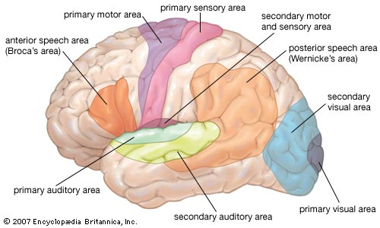  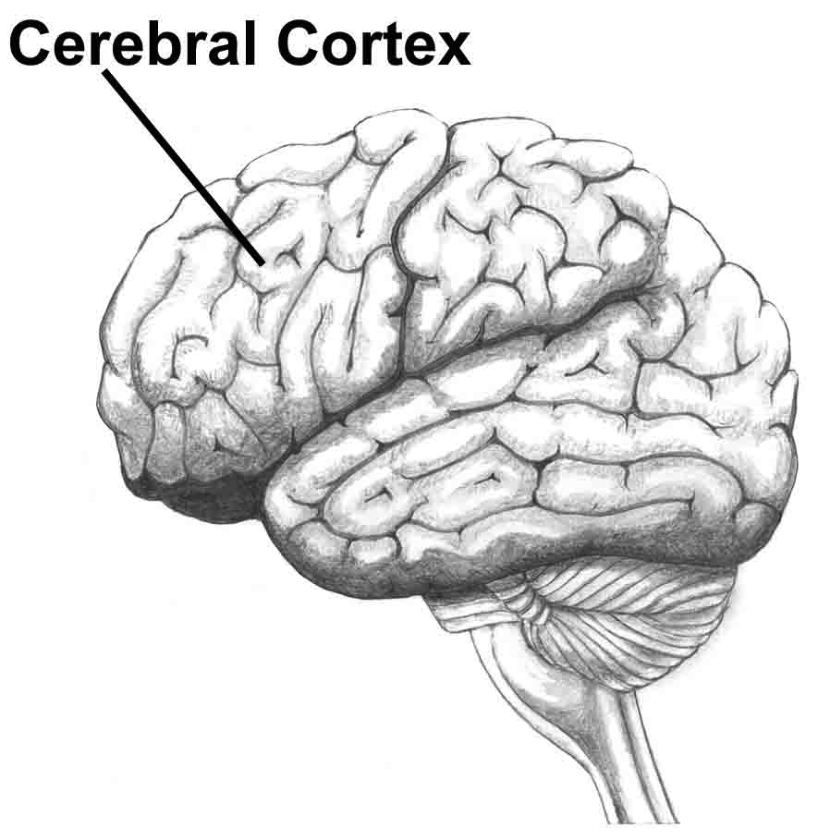
Function of the cerebrum
Function of the cerebellum | 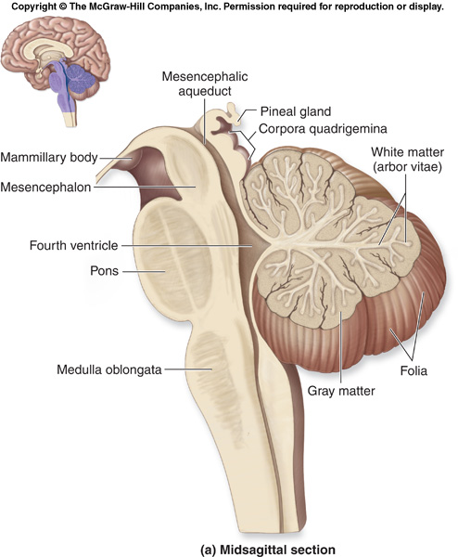
Function of the hypothalamus | 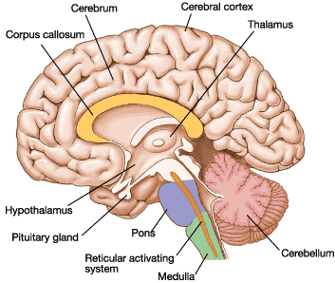
Function of the medulla oblongata

Structure of the spinal cord | 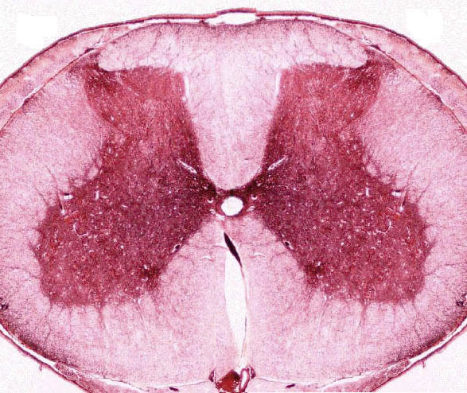  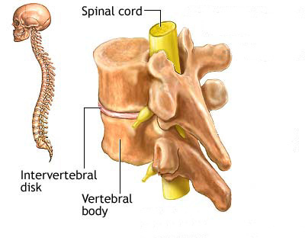
Function of the spinal cord

